## **1.3 - Canny Edge Detection (DFS Implemented)**

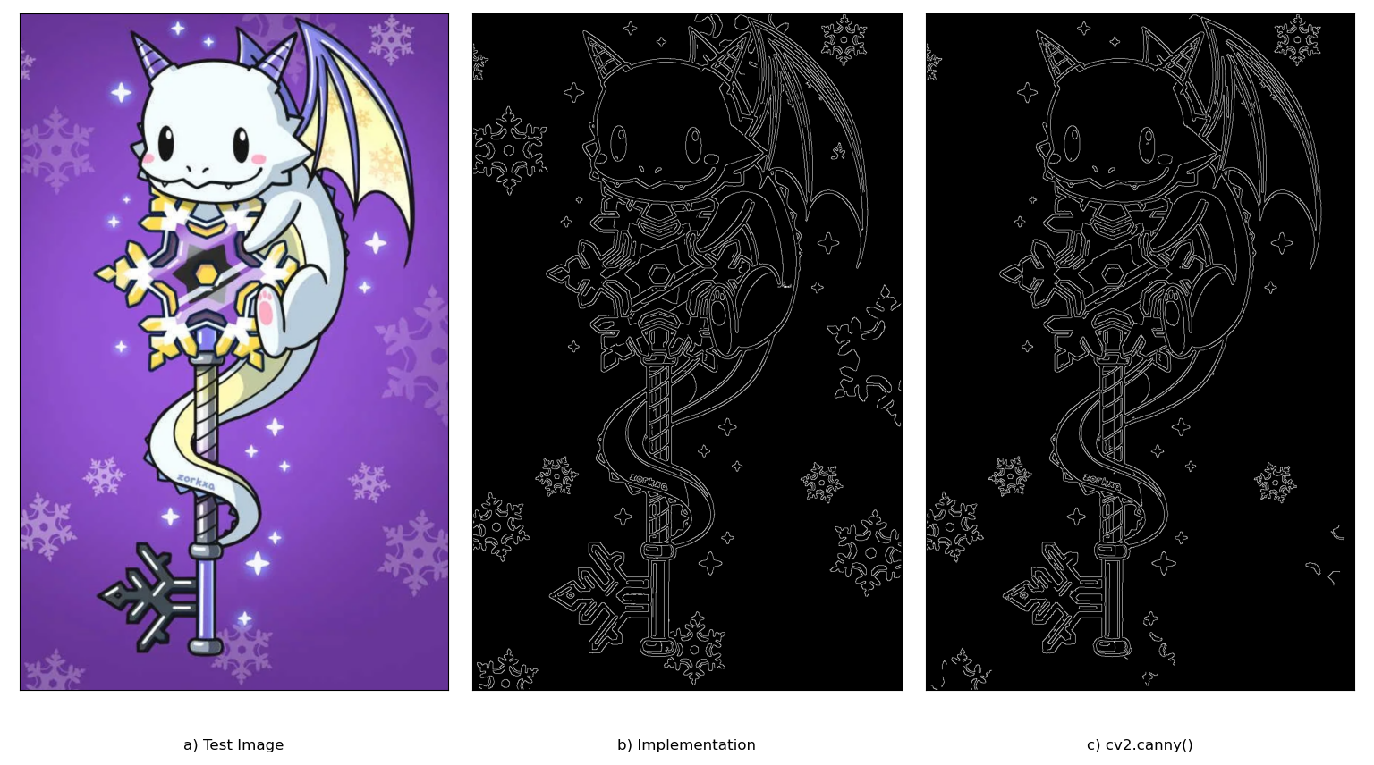

Given a test image (image A above), the implementation provided by OpenCV performed comparatively similarly to a manual implementation. Both implementations follow the basic mechanics of Canny Edge Detection:

1. Noise reduction using a 5x5 gaussian filter
2. Gradient intensity calculation using a pair of Sobel filters
3. Non-Maximum Suppression
4. Hysteresis using a depth first search to propagate edges

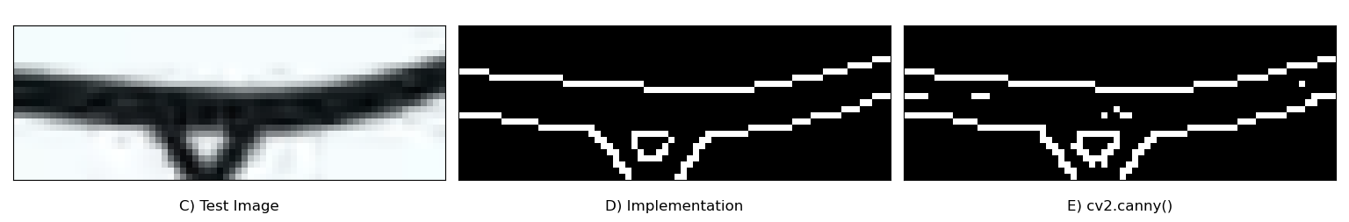

Our algorithm unexpectedly seems more resistant to image noise (image D, E). This difference could be attributed to the thresholding values for the hysteresis step. In the manual implementation, threshold values are quantified as percentages of pixel values relative to the strongest pixel in the image. In OpenCV’s implementation, threshold values are considered as gradient intensity values. In a window of non-relevant pixels, a compression artifact’s pixel value could theoretically result in a phantom gradient magnitude with enough significance to pass OpenCV thresholding while simultaneously being too low of a value to pass ours.